NETWORKING IP ADDRESS
To check IP ADDRESS in centos 7 tempary ip address
[root@server1-UA ~]#ifconfig elp1s6 192.168.0.150
To see IP ADDRESS [root@server1-UA]#ifconfig
Assign the IP ADDRESS permant
[root@server1-UA ~]#nmtui
2. Select edit connection and enter OK to continue. (Use tab key to navigate).
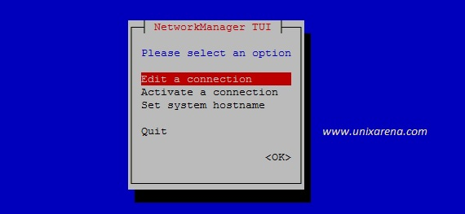
3. Here you can see the current network profile (System eth0). Select the “Add” and press enter to add new connection profile.
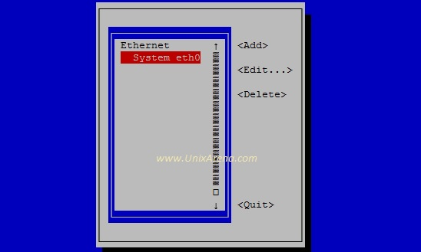

Once you select “Add”, you will get the below screen. Select “Ethernet” and create it .
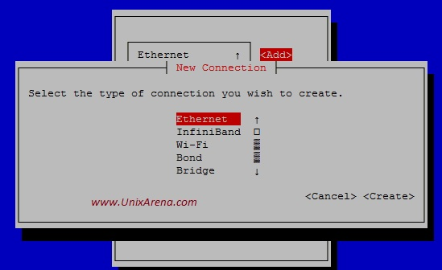
5.Enter the new profile name and device name(existing device) for the new connection. Select the “Automatic” and press enter.
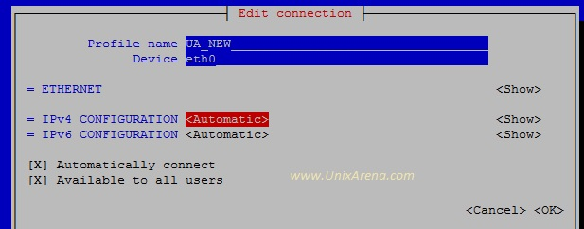
6.You will get a option to select the connection type like below. Select “Manual” , if you want to configure the “static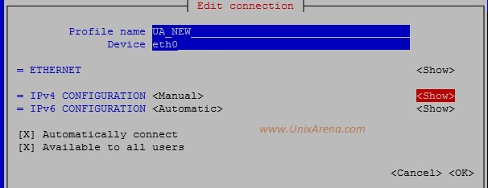
7. Enter the IP, gateway and DNS server’s details. Click “OK” to complete it .
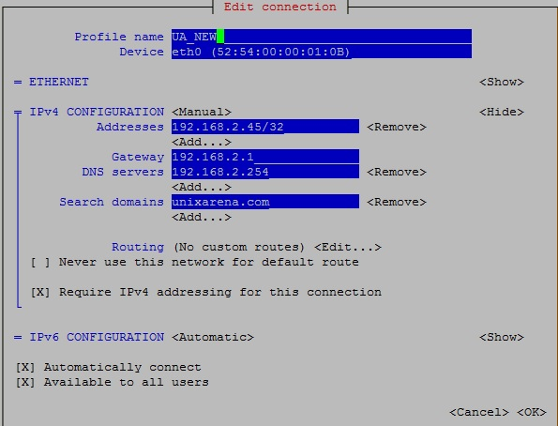
8. Quit the nmtui.
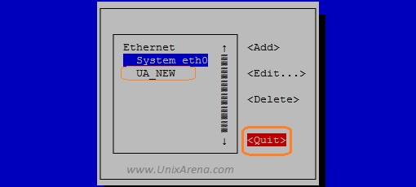
At this point, we have successfully created the new network connection profile. But yet to activate it.
Then [root@server1-UA ~]#service network restart (Enter)
Ping to ip Service [root@server1-UA ~]#ping 190.168.0.250 (ctrl+c)stOP

CONFIGURATION OF STATIC IP (CENT OS 6)
this will launch a new window select network configuration
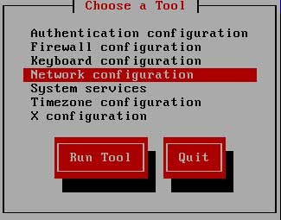
now a new window will show you all available LAN card select your LAN card ( if you don’t see any LAN card here mean you don’t have install driver)

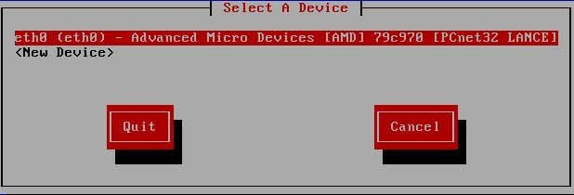
Assign IP in this box and click ok

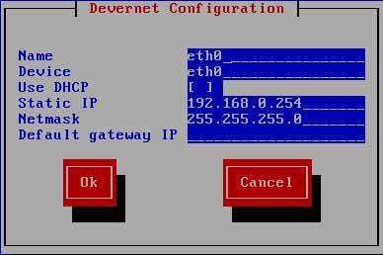

Whatever change you made in network configuration will not take place till you restart the LAN card
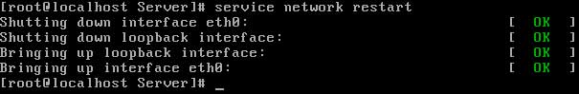
Ifconfig
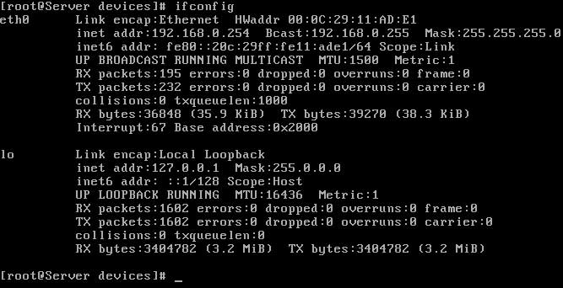

ifup/ifdown

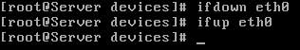
#ifup ifcfg-eth0 #ifup eth0

Netstat

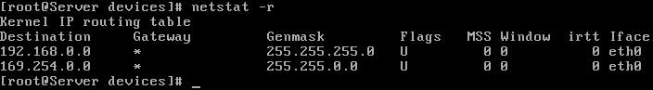

arp

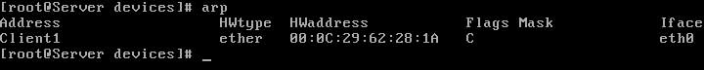

ping
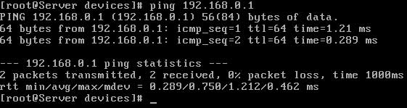

service network restart

Network IP hostname
1.To assign network hostname temporary
[root@localhost~] #hostname nfsservet.tesync.com
2.To check the file #vi /etc/hostname
OUT PUT Type nfsservet.tesync.com
3. To add the system ip with system name #vi /etc/hosts
O/p Type 127.0.0.1 local-host local domain local host
192.168.119.128 nfsserver.tesync.com nfsserver
After logoff and login to update hostname
4.[root@nfsserver~]#hostname -s
5.To check system domain name and ip address
#hostname –d #hostname –i
6. Ping with system name #ping nfsserver

